Asia-China-Coin-Flat Handle-Wang Mang-Collection

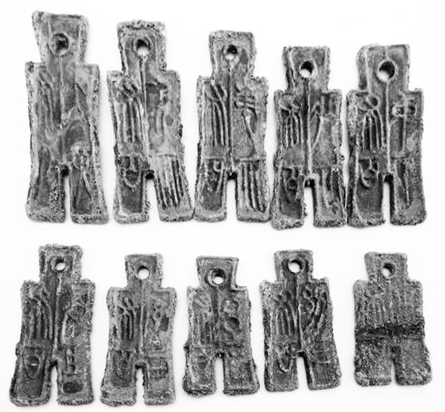

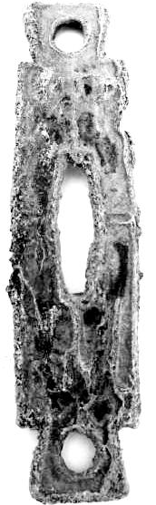 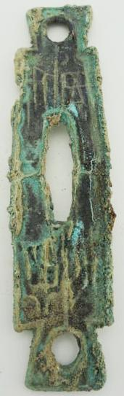

Square Foot Spade, Dang Jin type, Obv. Si Bi, Rev, Dang Jin, H 3.468 R 4, weight:12g

size : leight 3.0 inches*width 0.79 inches

|  |  |
| --- | --- |
|  | “古代钱币，连裤形状” |

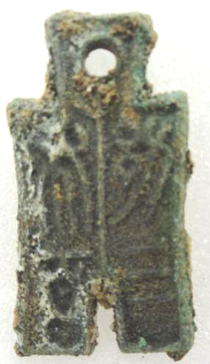 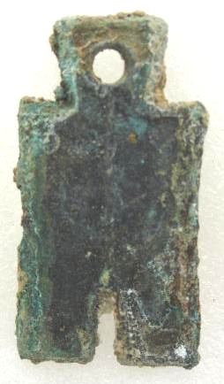

H 9.23 R 5

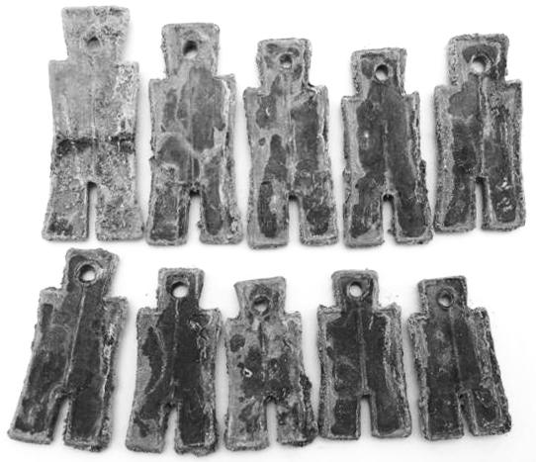

# Tools of the trade in ancient China,Han dynasty last years,Wang Mang Shi Bu,set

9 views

### Seller information

|  |  |
| --- | --- |
|  | | [Add to watch list](http://cgi1.ebay.com/ws/eBayISAPI.dll?MakeTrack&_trksid=p2047675.l1359&rt=nc&item=141145347963&tagId=-99&sourcePage=4340&ssPageName=VIP:watchlink:top:en&wt=34c9019869718e76489047b0cc1c048b&etn=Watch list) |

[lengxue](http://myworld.ebay.com/lengxue?_trksid=p2047675.l2559) ([27](http://feedback.ebay.com/ws/eBayISAPI.dll?ViewFeedback&userid=lengxue&iid=141145347963&ssPageName=VIP:feedback&ftab=FeedbackAsSeller&rt=nc&_trksid=p2047675.l2560) ) 

100% Positive feedback

[Follow this seller](http://www.ebay.com/itm/141145347963)

[See other items](http://www.ebay.com/sch/lengxue/m.html?item=141145347963&rt=nc&_trksid=p2047675.l2562)

|  |
| --- |
|  |
| [AdChoice **- opens in a new window or tab**](javascript:void(0);) |

Top of Form

## Item Information

Item condition:

--not specified

“王莽时期货币，复制品”

Time left:

22d 01h (Jan 18, 2014 16:01:21 PST)

Quantity:

2 available /   [1 sold](http://offer.ebay.com/ws/eBayISAPI.dll?ViewBidsLogin&_trksid=p2047675.l2564&rt=nc&item=141145347963) in 1 hour

Price:

US $19.99

Bottom of Form